Question:
Find the missing term in a given finite difference table using Python.
Aim:
Write a Python program to demonstrate to find the missing term in a finite difference table.
Program:
def solve_five_point(y):
# Coefficients for the formula:
# y4 - 4y3 + 6y2 - 4y1 + y0 = 0
coeffs = [1, -4, 6, -4, 1]

if y.count(None) != 1:
print("Error: Exactly one value must be 'null'.")
return None

missing_index = y.index(None)
total = 0

for i in range(5):
if i != missing_index:
total += coeffs[i] * y[i]

# Solve for the missing value
y_missing = -total / coeffs[missing_index]
return missing_index, y_missing

def check_equal_spacing(x):
h = x[1] - x[0]
for i in range(1, len(x) - 1):
if abs((x[i + 1] - x[i]) - h) > 1e-6:
return False
return True

def main():
print("Enter x values (must be equally spaced):")
x = []
for i in range(5):
try:
x_val = float(input(f"x[{i}]: "))
x.append(x_val)
except ValueError:
print("Invalid x value.")
return

if not check_equal_spacing(x):
print("Error: x values are not equally spaced.")
return

print("Enter y values (use 'null' for missing value):")
y = []
for i in range(5):
val = input(f"y[{i}]: ")
if val.lower() == "null":
y.append(None)
else:
try:
y.append(float(val))
except ValueError:
print("Invalid y value.")
return

result = solve_five_point(y)
if result:
idx, missing_y = result
print(f"\nMissing value y[{idx}] = {missing_y:.4f}")

if __name__ == "__main__":
main()
Result:
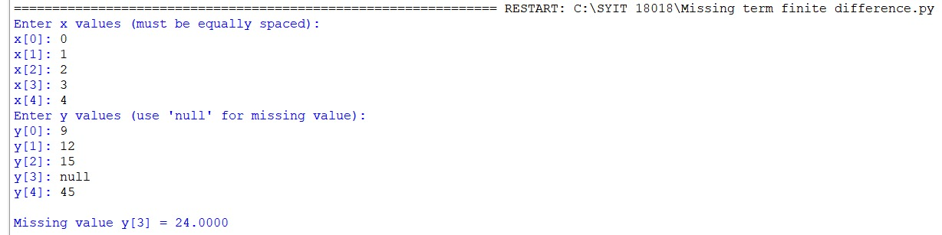
Conclusion:
The above Python program has been executed successfully.

